**Week-07-Searching Algorithms-Linear and Binary**

**Week 07-01-practice session coding**

**Reg no :241001159**

**Name : PADMAVATHy.M**

**Q1)**

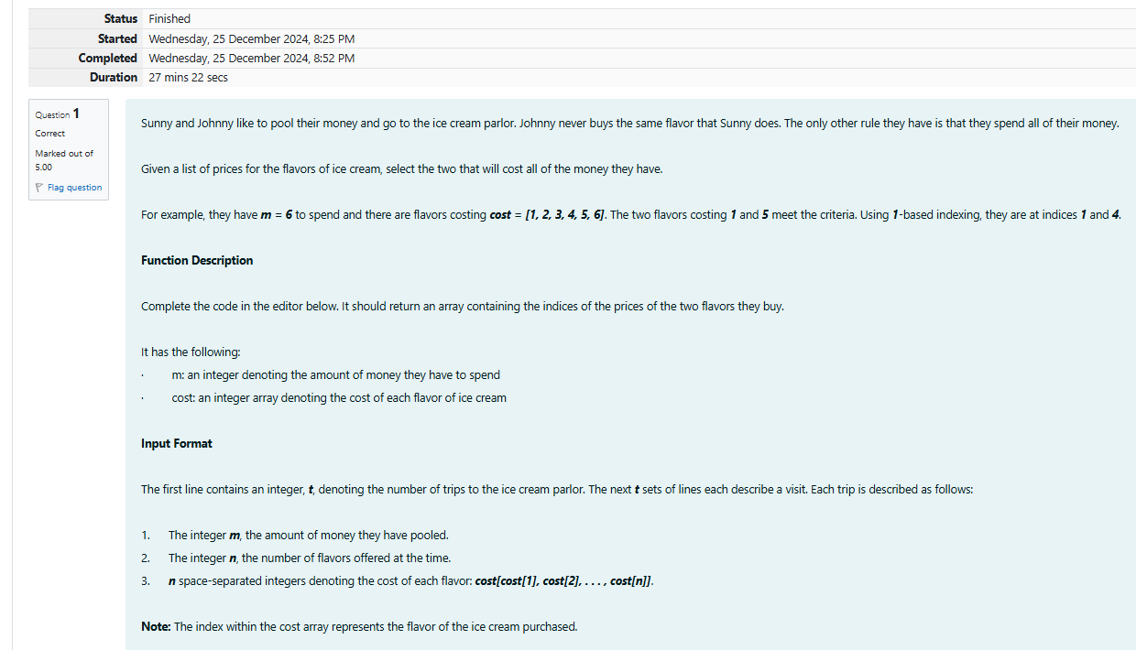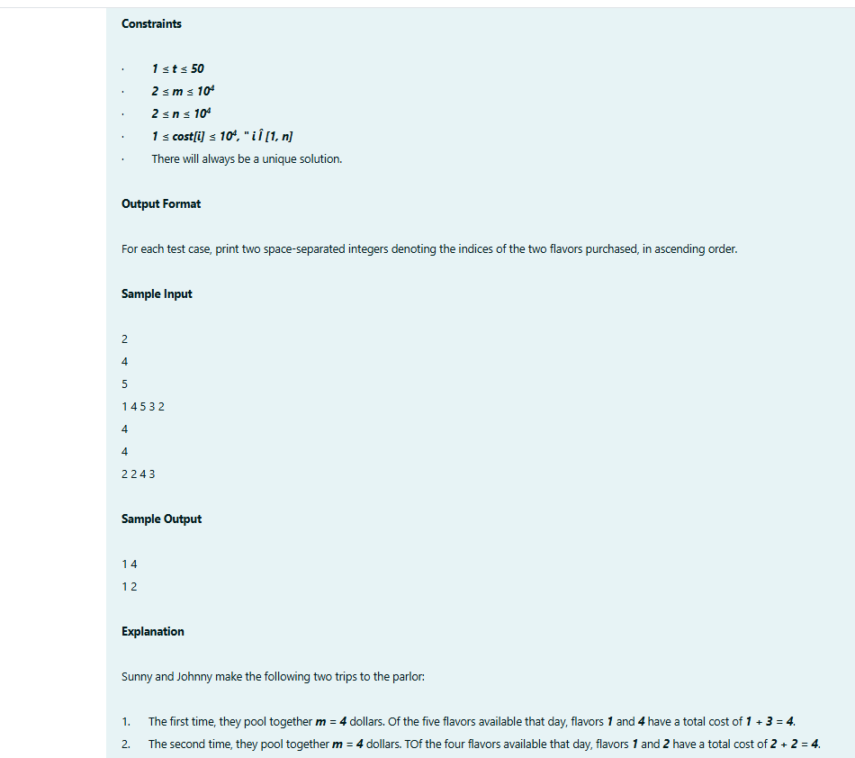

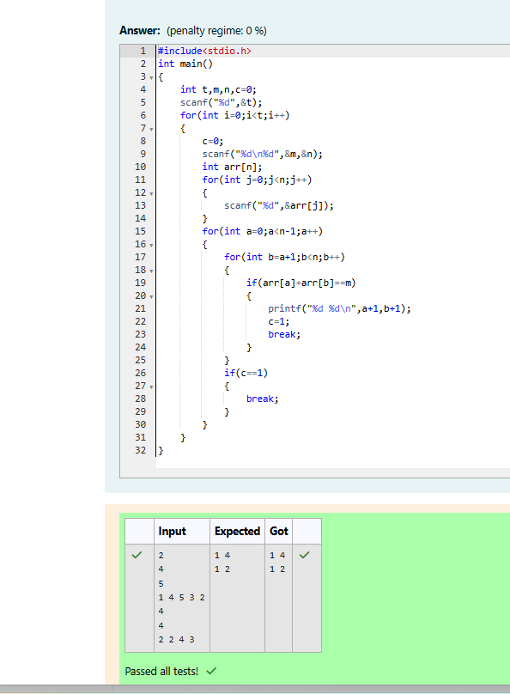

**Week 07-01-practice session coding**

**Reg no : 241001159**

**Name : PADHMAVATHY.M**

**Q2)**

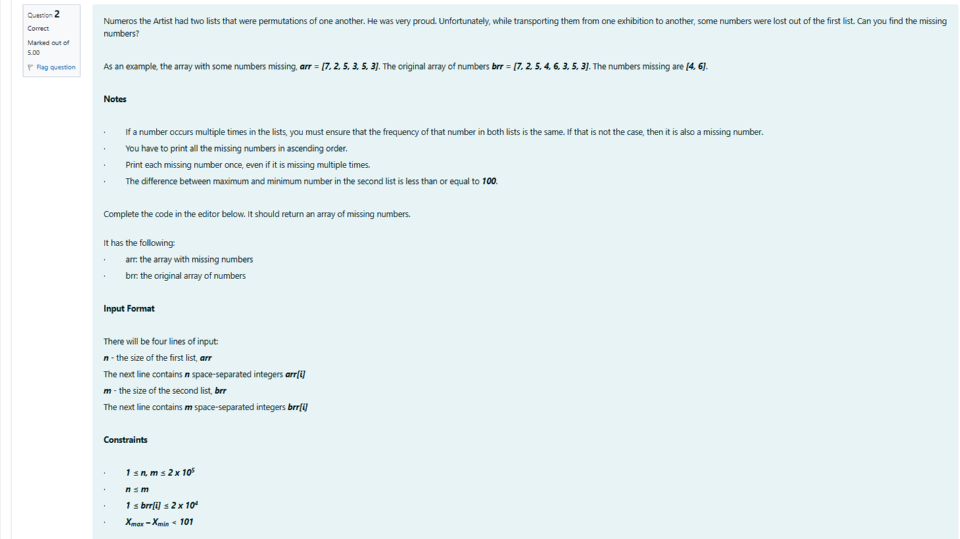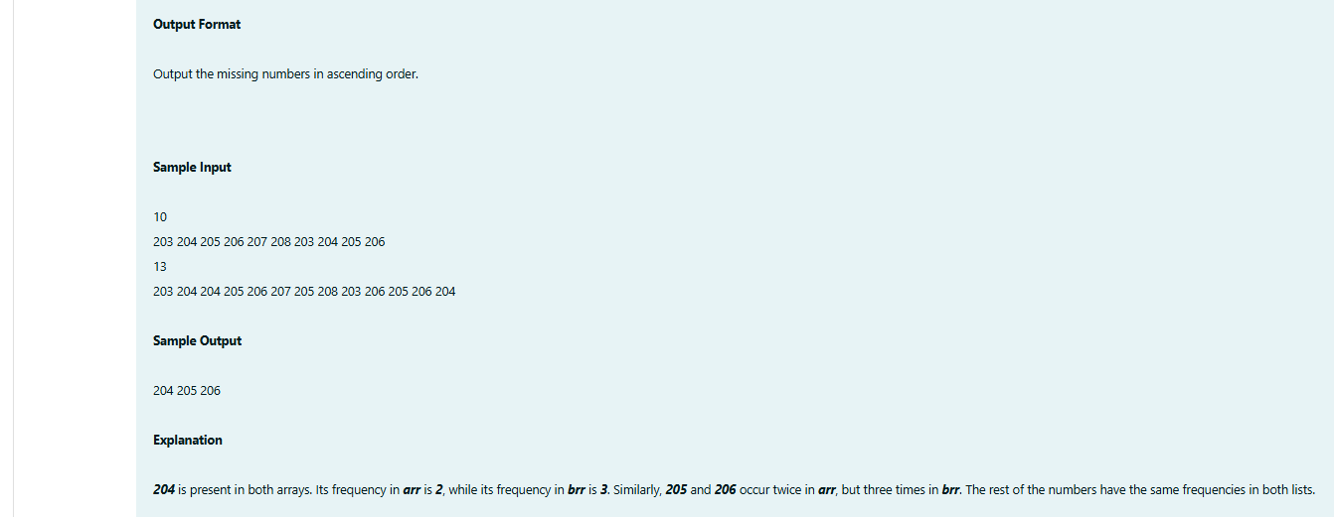

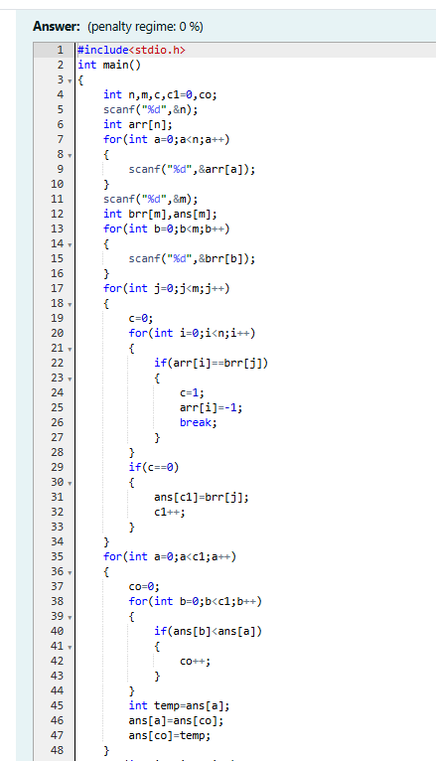

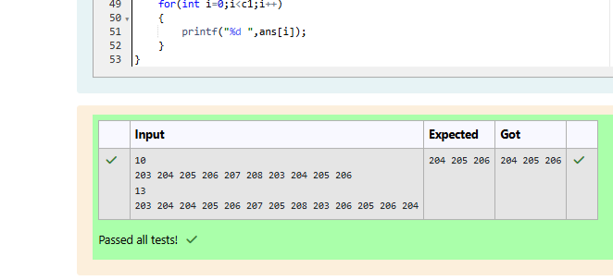

**Week 07-01-practice session coding**

**Reg no : 241001159**

**Name : PADHMAVATHY.M**

**Q3)**



